|  |  |
| --- | --- |
|  | Solar Light Project  Definition and Plan |

The solar light project will challenge students to consider how to make a portable LED light more efficient and sustainable. The project should take **~22 hours** to complete, with a proposed **6 month** schedule. It is intended for students aged 10 to 16 who have some background knowledge of electronics (e.g. they have completed the HMG Foundation Activities) but can easily be adapted for an older audience by adding complexity to the design challenge part of the project.

Table of Contents

[The Problem – Lights Powered by Non-Rechargeable Batteries 2](#_Toc531703035)

[The Solution – Light with a Solar Powered Rechargeable Battery 2](#_Toc531703036)

[Needs 3](#_Toc531703037)

[Constraints 3](#_Toc531703038)

[Materials and Costs per Group 4](#_Toc531703039)

[Design Challenge 5](#_Toc531703040)

[6 Month Plan 5](#_Toc531703041)

[Month 1 – Introduction 6](#_Toc531703042)

[Month 2 – Topic Activities 6](#_Toc531703043)

[Month 3 – Build the Prototype 6](#_Toc531703044)

[Month 4 – Test the Prototype 6](#_Toc531703045)

[Month 5 – Design Challenge 6](#_Toc531703046)

[Month 6 – Project Exhibition 6](#_Toc531703047)

[Building the Example Prototype 7](#_Toc531703048)

[Circuit Diagram 7](#_Toc531703049)

[Charging 7](#_Toc531703050)

[Discharging 7](#_Toc531703051)

[Breadboard Prototype 8](#_Toc531703052)

[Topic Activity Resources 8](#_Toc531703053)

[How Diodes Work 8](#_Toc531703054)

[Introduction to Solar Panels 8](#_Toc531703055)

[Electric Power 9](#_Toc531703056)

[Calculating Solar Panel Size for a Desired Power Output 9](#_Toc531703057)

[LED Circuit and Load Power 9](#_Toc531703058)

[Types of Batteries 10](#_Toc531703059)

[Power Capacity 10](#_Toc531703060)

[Solar System Design 10](#_Toc531703061)

The Problem – Lights Powered by Non-Rechargeable Batteries

Our objective is to make a bright and portable LED light. Traditionally such a light has been powered by a non-rechargeable battery. When this battery is empty it must be thrown away, which is harmful for the environment. Replacing batteries is also expensive.

***Powering an LED light from a non-rechargeable battery is harmful to the environment and expensive to power for long periods.***

**How can we make an LED light more reusable, sustainable, and inexpensive to use for hundreds or thousands of hours?**

The Solution – Light with a Solar Powered Rechargeable Battery

|  |  |
| --- | --- |
| There are many possible solutions to the problem of non-rechargeable batteries, including powering the light directly from a wall plug or using rechargeable batteries. We’ve chosen to explore powering the LED light from a solar-powered rechargeable battery as a promising solution to the problem.  Solar panels can recharge a battery anywhere using the sun. They are portable, reliable, inexpensive, and widely accessible. | C:\Users\Harryp\MEGA\Surface Pro 2\Nepal\Himalayan Makers Guild\Activities\Projects\Project Solar\images\flaticon\battery-charging-with-solar-panel2.png[[1]](#footnote-1) |

Solar panels also have some weaknesses: They do not provide power when it is cloudy or dark, or if they get dirty. They can also be fragile.

**We will be building an LED light powered by a small rechargeable battery and solar panel.**

Needs

The light must:

1. Light one white LED (5mm) for 6 hours at full brightness (50mW).
2. Fully recharge in 6 hours under typical sunny conditions.

Constraints

Some limitations for our design include:

* Time: The light must be built in fewer than ten 1.5-hour activity sessions
* Materials:

|  |  |  |
| --- | --- | --- |
| 1x | C:\Users\Harryp\MEGA\Surface Pro 2\Nepal\Himalayan Makers Guild\Activities\Projects\Project Solar\images\part 4v battery.JPG | Lead-Acid Battery (4V, 1Ah) |
| 1x | C:\Users\Harryp\MEGA\Surface Pro 2\Nepal\Himalayan Makers Guild\Activities\Projects\Project Solar\images\2018-05-04 18_48_14-Untitled Sketch.fzz_ - Fritzing - [Breadboard View].jpg[[2]](#footnote-2) | 5mm LED (White) |
| 1x |  | Diode (1N4001) |
| 2x | C:\Users\Harryp\MEGA\Surface Pro 2\Nepal\Himalayan Makers Guild\Activities\Projects\Project Solar\images\part solar panel.JPG | Solar Panel[[3]](#footnote-3)  (3V, 120mA, 6cm x 6cm) |

Basic electronic components (wires, switches, resistors, capacitors, etc.), breadboards, and basic building supplies (cardboard, glue, tape, etc.) will also be available for building the light.

Materials and Costs per Group

These costs are for the basic prototype described in §Needs and Constraints and §Building the Example Prototype and do not include costs associated with the §Design Challenge part of the project (e.g. other types of batteries, solar panels, LEDs; voltage converters, USB cables, etc.). Design challenge costs are expected to be $10 CAD per group.

Assuming one kit of parts per group of 3-4 students:

|  |  |  |  |  |
| --- | --- | --- | --- | --- |
| Item | Qty. | Cost per Group[1](#fn:1) | Expendable[2](#fn:2) | Supplier |
| Resistor, 100ohm, 1/4W | 1 | 0.01 | Yes | AliExpress |
| Jumper cables MM MF FF 10cm | 10 | 0.19 | Yes | AliExpress |
| Breadboard 400 point | 1 | 1.49 |  | AliExpress |
| Diode (IN4001) | 1 | 0.01 | Yes | AliExpress |
| LED 5mm white | 1 | 0.04 | Yes | Ason, Kathmandu |
| SPST Switch | 1 | 0.19 |  | Ason, Kathmandu |
| Battery, lead-acid, 4V, 800mAh | 1 | 0.77 |  | Ason, Kathmandu |
| Solar Panel, 3V, 120mA, 6cm x 6cm | 2 | 2.56 |  | Ason, Kathmandu |
| Total Cost per Group |  | **$5.26 CAD** |  |  |

1. *Currency is CAD, 2017-06-10. Assuming one set of parts per student.*
2. *Likely to be broken or lost during the activity.*

Additional items that should be provided include building materials for the box that contains the light such as cardboard, thin wood, paper, recycled plastic containers, straws, popsicle sticks, tape, glue, and aluminum foil. Also, tools such as scissors, box-cutters, wire cutters, and rulers should be available for use.

Design Challenge

The students will work in groups to create the same basic solar light prototype as described in §Needs and Constraints and §Building the Example Prototype. Each group will then be challenged to improve their design by adding extra functionality. Each group will try to implement a specific improvement. The groups should be encouraged to come up with their own improvements after testing their prototypes. However, if they need some extra guidance possible improvements include:

* Given a specific solar panel, build a light and battery system to match it.
* Given a specific battery, build a panel and light system to match it.
* Build a system with higher power LED lights
* Add the ability to charge the battery from a 5V USB connection.
* Add the ability to use the solar light as a USB power bank providing a 5V output.

6 Month Plan

This plan is structured assuming three 1.5-hour project sessions per month. The plan is guided by the [Engineering Design Process](https://www.teachengineering.org/k12engineering/designprocess)[[4]](#footnote-4) and refers to it as follows:

* EDP1: **Define** the problem, needs, and constraints
* EDP2: **Research** the problem and related technology
* EDP3: **Imagine** possible solutions
* EDP4: **Select** a promising solution
* EDP5: **Build** a prototype
* EDP6: **Test** the prototype
* EDP7: **Improve** the solution

Prior to building the basic prototype the students should be introduced to key concepts through hands-on activities (see §Topic Activity Resources for more information):

* How diodes work
* Introduction to solar panels
* Electric Power
* Calculating solar panel size
* LED circuit and load power (how you can change the load... voltages/current, power/brightness, calculating the power load)
* Types of batteries (Lithium, lead acid, NiMh; charging, discharging, voltages, lifespan)
* Electric power capacity
* Solar power system design (power calculation of load, battery, panel)

Where necessary extra topic activities should be arranged to match the design challenges, for example:

* Voltage level conversion (basics of buck, boost, and voltage regulators)
* Using lithium batteries (how they work, charge/discharge properties, safety)
* Managing higher power LEDs (current and heat issues, basic drive circuits)

Month 1 – Introduction

1. Introduce the problem (EDP1), form the groups, and discuss possible solutions (EDP3)
2. Choose the best solution (EDP4) and present the example prototype of the solar light the students will build (see §Building the Example Prototype). Discuss the needs and constraints of the light(EDP1)
3. Topic activities (EDP2, EDP5): How diodes work

Month 2 – Topic Activities

1. Topic activities (EDP2, EDP5): Introduction to Solar Panels
2. Topic activities (EDP2, EDP5): Electric power
3. Topic activities (EDP2, EDP5): Calculating Solar Panel Size for a Specific Power need

Month 3 – Build the Prototype

1. Topic activities (EDP2, EDP5): LED circuit and load power
2. Topic activities (EDP2, EDP5): Types of Batteries
3. Topic activities (EDP2, EDP5): Electric power capacity

Month 4 – Test the Prototype

1. Topic activities (EDP2, EDP5): Solar system design
2. Build the prototype, continued (EDP5)
3. Test the prototype (EDP6)

Month 5 – Design Challenge

1. Design challenge (EDP7)
2. Prepare for exhibition of project

Month 6 – Project Exhibition

1. Exhibit the project

Building the Example Prototype

An example prototype of the project should be built for demonstration to the students in Month 1 of the project. This design can also be used as a reference when helping the students troubleshoot their prototypes.

Circuit Diagram

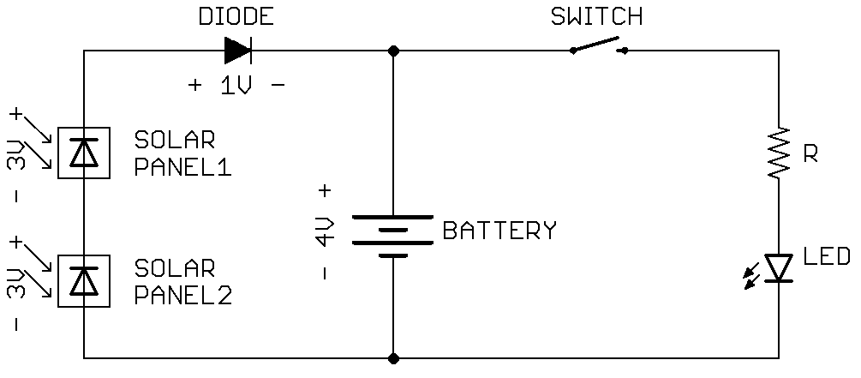

Charging

Current flowing into the battery is limited to a safe level (~1/10th of the battery’s capacity) by the solar panels, which have a maximum current of 120mA.

If it becomes dark, some current can flow backwards through the solar panels (~20mA) draining the battery. To prevent this, a diode is used between the battery and panels.

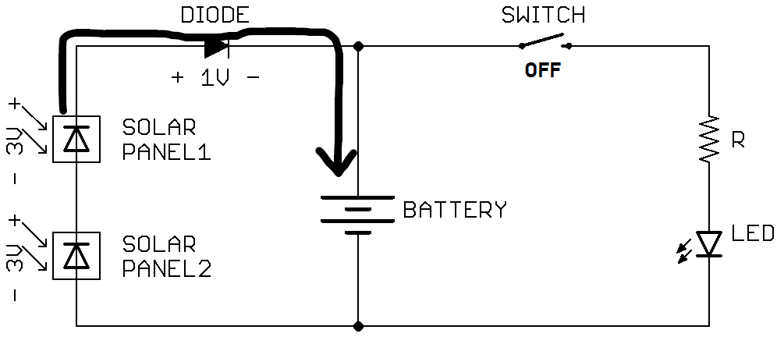

Discharging

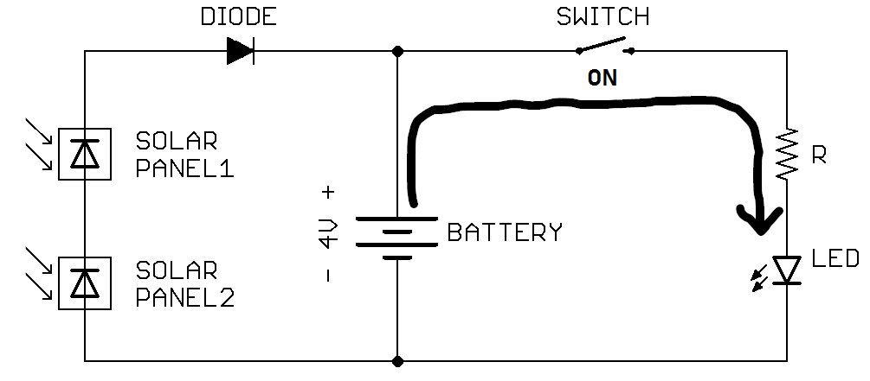

Breadboard Prototype

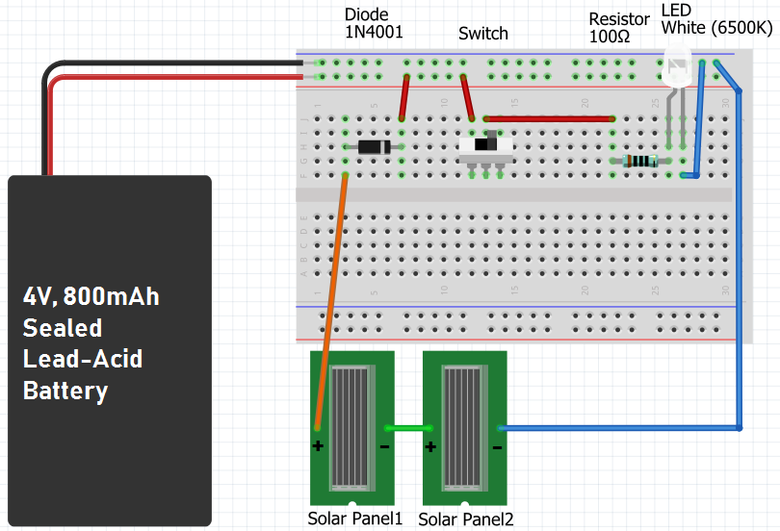[[5]](#footnote-5)

Note: solar-panels not to scale.

Topic Activity Resources

How Diodes Work

|  |  |
| --- | --- |
| Activity Goal: | Understand the PN junction of a diode, and how they can create light (in a way, the opposite of a solar panel). |
| Hands-On: | Test behavior of diode (one-way current flow). Measure the voltage created by shining a light on 10 LEDs in parallel. |
| Resources: |  |

* <https://www.imagesco.com/articles/photovoltaic/photovoltaic-pg3.html>
* <http://www.studentsheart.com/pn-junction-diode/>
* <https://www.youtube.com/watch?v=lJI8Ee3ZiUY>
* <https://youtu.be/b3xys6rYM_Q?t=552>

Introduction to Solar Panels

|  |  |
| --- | --- |
| Activity Goal: | Understand how solar panels convert light energy into electrical energy. |
| Hands-On: | Measure the voltage output of a small solar panel under different light conditions. |
| Resources: |  |

* <https://www.imagesco.com/articles/photovoltaic/photovoltaic-pg4.html>
* <https://learn.adafruit.com/collins-lab-solar?view=all>
* <https://youtu.be/JxOTulMExWU?t=192>

Electric Power

|  |  |
| --- | --- |
| Activity Goal: | Define electrical power and calculate the power output of a solar panel. |
| Hands-On: | Measure the voltage and current of different solar panels under different light conditions to understand their range of power outputs. |
| Resources: |  |



$Power \left[Watts\right]=Voltage \left[Volts\right] ×Current \left[Amps\right]$ $$P=VI$$

Calculating Solar Panel Size for a Desired Power Output

|  |  |
| --- | --- |
| Activity Goal: | Assuming the same efficiency, use the known power and area of a solar panel to calculate the size of panel needed for a desired power output. |
| Hands-On: | Measure the area of different solar panels with a known power output. Using power and area, calculate the size of panel needed to get different amounts of power (e.g. 1W, 120W). |
| Resources: |  |

$Power \left[Watts\right]=Voltage \left[Volts\right] ×Current \left[Amps\right]$ $$P=VI$$

* Assuming the same solar panel efficiency: $$\frac{Power of known solar panel [Watts]}{Area of the known solar panel [meters squared]}=\frac{Desired Power [Watts]}{Area needed \left[meters squared\right]}$$

$$\frac{P_{1}}{A_{1}}=\frac{P_{2}}{A_{2}}$$

LED Circuit and Load Power

|  |  |
| --- | --- |
| Activity Goal: | Use parallel and series combinations of LEDs to 1) maximize the power efficiency by using as many series LEDs as possible in series for a given battery voltage 2) calculate the resistance value to get maximum brightness 3) Use multiple series resistor and LED circuits in parallel to match the desired load power. |
| Hands-On: | Design, build, and test an LED load for a given supply voltage and desired load power. |
| Resources: |  |

* As much voltage as possible in a series of LEDs (with one resistor to limit current) should be dropped across the LEDs, and not the resistor, so that the power is converted into light rather than heat in the resistor. Assuming an ideal battery (constant voltage), the number of LEDs used in series is: $$number of LEDS in series<\frac{battery voltage}{turn-on voltage of one LED}$$
* See Foundation Activity FA6 – Ohm’s Law to see how to calculate the resistor value to get the ideal current for the LEDs
* Once we’ve selected the optimum number of LEDs to have in series, and found the resistor to get the ideal current for the LEDs, each one of these series circuits added in parallel will add a more power to the load according to this relationship:
* <http://www.talkingelectronics.com/projects/30%20LED%20Projects/30%20LED%20Projects.html>

Types of Batteries

|  |  |
| --- | --- |
| Activity Goal: | Consider the key characteristics of rechargeable batteries and compare some common types for use in different applications. |
| Hands-On: | Test the voltage and current of an assortment of different batteries. Calculate the number of cells in series in a 12V lead acid battery. |
| Resources: |  |

* <https://batteryuniversity.com/index.php/learn/archive/whats_the_best_battery>

Power Capacity

* <https://learn.adafruit.com/all-about-batteries/power-capacity-and-power-capability>
* <http://www.instructables.com/id/Complete-Guide-for-Tech-Beginners/>

Solar Power System Design

1. Solar icon modified from an icon by [Freepik](http://www.freepik.com) from [www.flaticon.com](https://www.flaticon.com/), licensed by [CC 3.0 BY](http://creativecommons.org/licenses/by/3.0/) [↑](#footnote-ref-1)
2. Part Images from Fritzing [↑](#footnote-ref-2)
3. Alternatively, 1x 6V, 100mA solar panel could be used. [↑](#footnote-ref-3)
4. https://www.teachengineering.org/k12engineering/designprocess [↑](#footnote-ref-4)
5. Image made using Fritzing [↑](#footnote-ref-5)